**SMOKE TEST OVERVIEW**

**Smoke Test modification:**

1. In Visual studio open “Subversion project “
2. Find it in SVN in : https://svn.tribune.com/dynamicsax/trunk/Tools/AIF%20Smoke%20Tester/
3. Refresh service reference if you need by right click and configure it
4. Modify code if you need
5. Build the solution and find the exe file in build solution at the bottom pane
6. Copy exe file in destination. Make sure AIFTest.exe XML is the one we need otherwise modify it manually in destination. In solution explorer it is seemed as app.config but when solution is built it will be saved as AIFtest.exe XML configuration.

Smoke Test Path: \\xen02\axfiles\AIF Smoke Test\QA 01

Application: AIFTest

Config file: AIFTest.exe

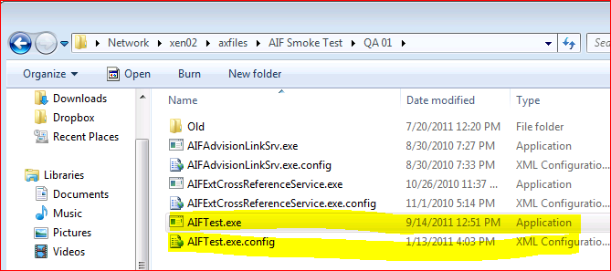

**Configuration file:**

QA Services MSM:

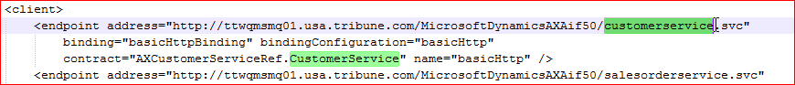

Identity (non Production – Dev Business Connector user):

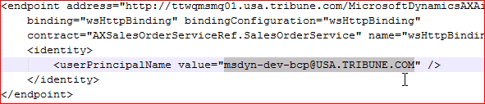

**Application:**

Adit Service Account - Active Directory Account: xsxOnlineAutomation: Production Adit User that connects to AX (may go away due to security concern)

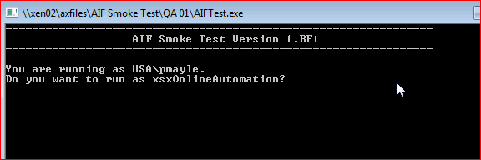

**AX ID for the Adit User on Order:**

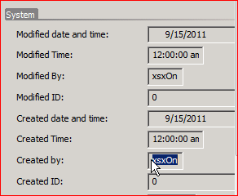

**Main Menu:**

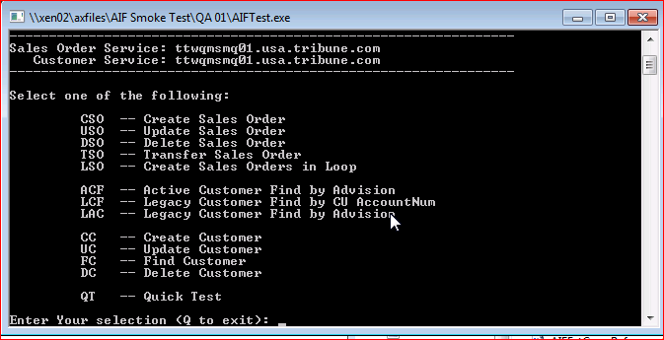

Company Configured (AIF enabled): DPR, TIC, CTC, LAT (Items are hardcoded)

The Transactions can be performed individually or as Quick Test

**QT Quick Test Functionality:** Create Update Customer, Update Create Sales Order, Find Sales Order, Delete Sales Order and Delete Customer

1. Create Customer:

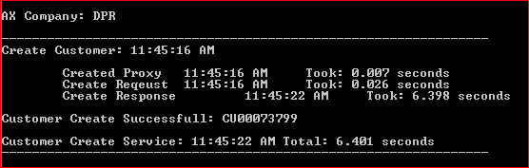

1. Update Customer:

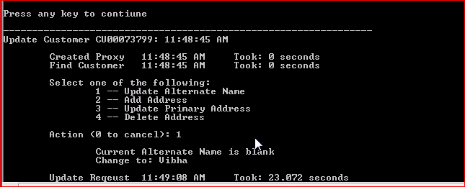

In AX (step 1 ad Step 2)

1. Create Sales Order:

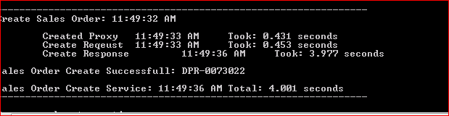

In Ax (step 2): Same lines and same attributes

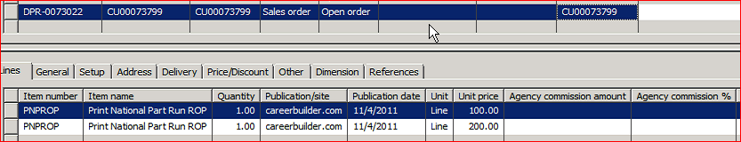

1. Find and Update (proposal Name is Customer ID)

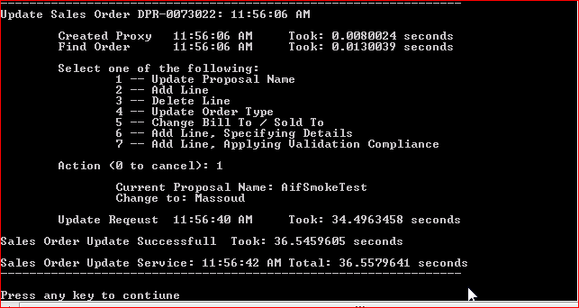

1. Delete the Sales Order

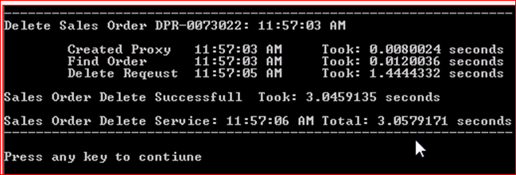

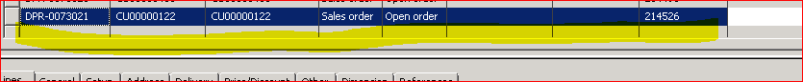

1. Delete the Customer

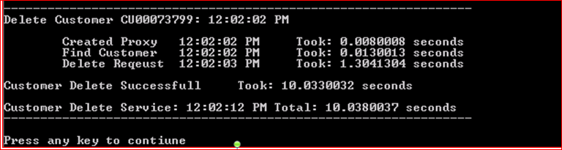

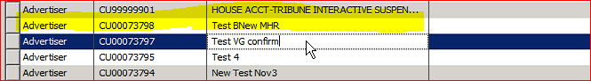

**AIF Smoke Test Code (subversion) - Require access to Visual Studio and source code**

Main Method (C Sharp)

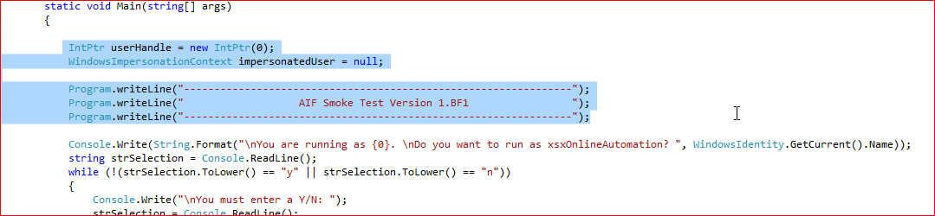

Create Sales Order: - Initiate and create Instance of - Service Class document Class (collection of table in AIF webservice) and Entity

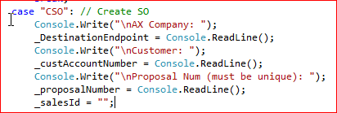

SalesTypecode Specified is required as the AX does not have null it is blank or 0 depending on data type.



Error Handling:

